5. CSS Box Model
- Theory Questions

- Explain the CSS box model and its components (content, padding, border, margin). How does each affect the size of an element?

Ans : The CSS box model is a way to visualize HTML elements as boxes with content, padding, borders, and margins. Each component affects the size of an element in a different way.

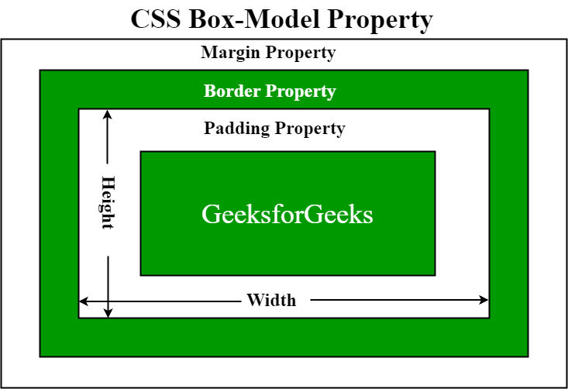

- Contents :
- The area where the element's content is displayed
- The size of the content box is determined by the amount of content, such as text or images
- The height and width properties can be used to change the size of the content box

- Padding :
- The space between the content and the border
- The padding property in CSS controls the amount of padding
- Increasing the padding increases the space around the content
- Padding can be applied to all sides of the box or to specific sides

- Border :
- The border that surrounds the content and padding
- The border property and its related properties control the border
- The border's color, style, and thickness can be changed
- Increasing the border's thickness increases the space around the padding

- Margin :
- The space between the border and the surrounding elements
- The margin property controls the amount of margin
- Increasing the margin increases the space between the element and other elements

- Explain The Concept Of Css Specificity. How Do Conflicts Between Multiple Styles Get Resolved?

Ans : If There Are Two Or More Css Rules That Point To The Same Element, The Selector With The Highest Specificity Will "Win", And Its Style Declaration Will Be Applied To That Html Element.

Priority | Example | Discription
Inline Style | <H1 Style="Color: Pink;"> | Highest Priority, Directly Applied With The Style Attribute
Id Selectors | #Navbar | Second Highest Priority, Identified By The Unique Id Attribute Of An Element
Classes And Pseudo-Classes | .Test, :Hover | Third Highest Priority, Targeted Using Class Names
Attributes | [Type="Text"] | Low Priority, Applies To Attributes
Elements And Pseudo-Elements | H1, ::Before, ::After | Lowest Priority, Applies To Html Elements And Pseudo-Elements

- What Is The Difference Between Internal, External, And Inline Css? Discuss The Advantages And Disadvantages Of Each Approach.
Ans : There Are 3 Ways to Implement the CSS in HTML document.

- Inline Css → Written Directly Inside An Html Tag.
- Advantages :
- Quick And Easy For Small Changes.
- No Need For External Files.
- Disadvantages :
- Hard To Maintain (Messy Code).
- No Reusability (Must Repeat On Each Element).
- Lower Performance (Increases Html Size).
Ex : <p style="color: blue; font-size: 20px;">This Is Inline Css</p>

- Internal Css → Defined In The <style> Tag Inside The Html <head>.
- Advantages :
- Better Organization Than Inline Css.
- Works For The Whole Page (Unlike Inline).
- No Need For Extra Files.
- Disadvantages :
- Still Not Reusable Across Multiple Pages.
- Makes Html File Larger.
Ex : <head>
<style>
p { color: blue; font-size: 20px; }
</style>
</head>
<body>
<p>This Is Internal Css</p>
</body>

- External Css → Defined In The <style> Tag Inside The Html <head>.
- Advantages :
- Best For Large Projects (Reusable).
- Improves Performance (Faster Loading).
- Keeps Html Clean And Organized.
- Disadvantages :
- Requires An Extra File.
- Won't Work If The Css File Is Missing.
Ex : <head>
<link rel="stylesheet" href="styles.css">
</head>
<body>
<p>This Is External Css</p>
</body>

